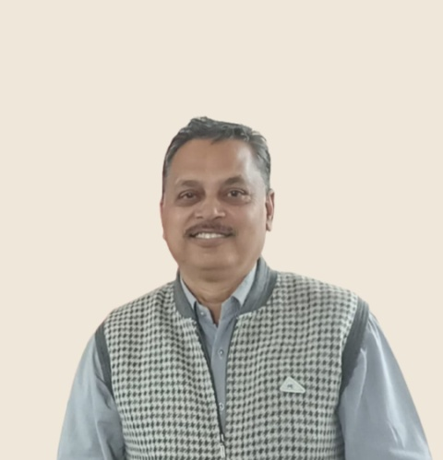 | President  Ashutosh Vyas  Affilation – Associate Professor, Department of Sociology, Maharana Pratap Govt. P.G. College, Chittorgarh MLS University Udaipur.  Email :-rsa.conference2013@gmail.com  Mobile :- 9414734714

Ashutosh Vyas is currently working as an Associate professor M.P Govt. P.G. College chittorgarh . He is more than 27 years of teaching, research and administrative experience. He has published/ edited 12 books and 34 research papers in reputed journals and his area of specialization are tribal studies, rural development, gender studies, social transformation.and Leisure studies, Under his supervision 05 candidates have been awarded Ph. D and four scholor are working under his Guidance. He has completed two research projects granted by UGC. He is a life member of several academic bodies viz, Indian Sociological Society, Sociological Society of Himachal Pradesh SAJATH , NWISA. He is also the convener of RC-15 Social Shange and transformation Indian sociological society since 2019. He shared his views as resourse person in FDP, Refresher Courses, National / International Confrences and Webinars. He has organized 1 International, 03 National, & Webinar, 01 State level Conference. He was earlier elected in RSA as the joint secretary (2012-15), secretary (2015-18) and vice president (2018-21).

